Patient Name ________________________________ Date ________________

Importance of Thickened Liquids

What Does That Mean for Patient Safety?

Regular liquid puts a patient at risk for fluid entering the trachea (tube to the lungs) rather than esophagus (tube to the stomach).

The build-up of food and drink in the lungs can cause lung infection and inflammation, and puts one at risk for developing aspiration pneumonia.

What Makes Regular Liquid Dangerous?

Thin liquid is the most difficult
substance to control in the mouth.

Especially for patients who are experiencing weakness, thin liquid can quickly and unexpectedly fall into the back of the throat before a swallow has started. Thin liquids also tend to break into several pieces in the throat instead of staying in one solid form.

How Do Thickened Liquids Help to Prevent Pneumonia?
• Thick liquids move more slowly down the throat, allowing more time to close and protect the airway.
• Thick liquids are easier to keep together in one piece, which helps ensure that they travel down only one tube – the esophagus.

REGULAR LIQUID: THICKENED LIQUID:
FALLS INTO THE AIRWAY: UNSAFE DOES NOT ENTER THE AIRWAY: SAFE

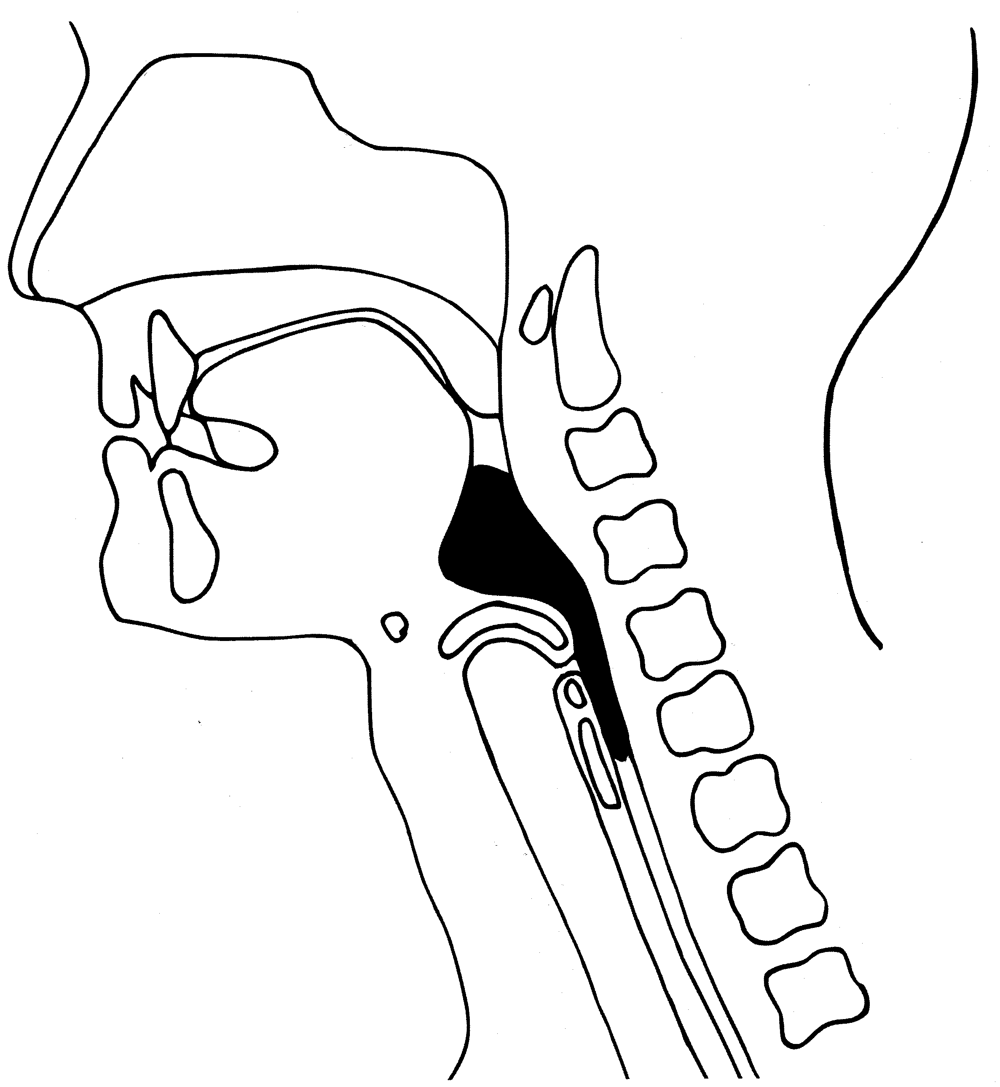
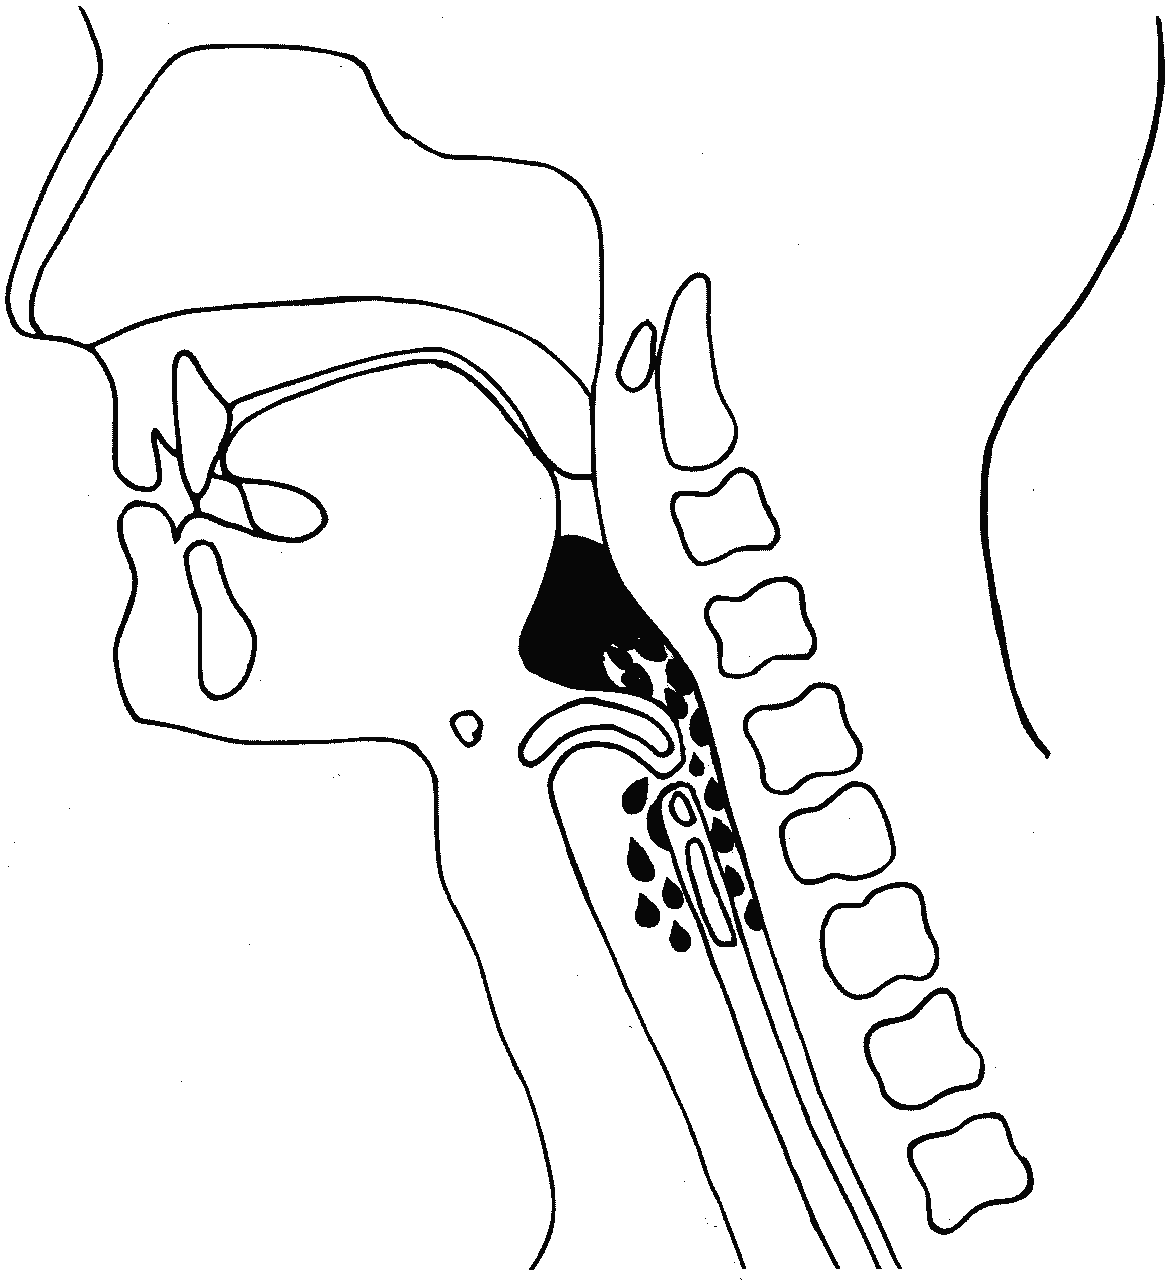

Liquid
Liquid
Esophagus
(to Stomach)
Esophagus
(to Stomach)
Airway
(to Lungs)
Airway
(to Lungs)

Currently, the safest liquid consistency for the patient as determined by a
speech-language pathologist is:

Nectar Liquids or Honey Liquids

How to Thicken Liquids

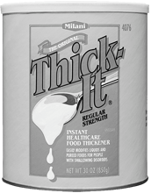
How Can I Thicken Liquids At Home?
First, obtain a thickening agent at your local drugstore. A popular brand is Thick-It, which can be found on the nutrition aisle of CVS, Walgreens, and Rite-Aid stores.

Thick-it is a starch-like powder that comes in a bright yellow canister. The powder is measured according to what type of liquid you are thickening and your desired consistency.

While stirring, mix powder into liquid with a spoon to avoid clumping. Let liquid stand for approximately 30 seconds to 1 minute before serving to reach desired thickness.

Pre-thickened, ready-to-serve liquids (water, milk, and juice) are also available for sale, but are more difficult to find in stores. Ordering online is the best option for pre-thickened liquids (see website links below).

What is the Difference Between Nectar and Honey?
Nectar liquids are comparable to Kern’s nectar juices or a melted milkshake.
Honey liquids pour off the spoon in a ribbon, just like honey.

The Spoon Test: Once you’ve mixed your liquid in a cup, attempt to balance a plastic spoon in the liquid without touching the cup’s edges. If the spoon stands straight up, you’ve made honey consistency. If it slowly droops toward the cup’s edge, you’ve made nectar consistency.

What Liquids Can I Thicken?
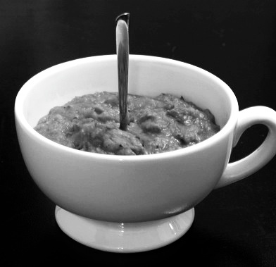
Most all liquids respond well to thickening products.
Liquids to thicken include (but are not limited to):
•Water •
•Milk •Coffee
•Juice •Tea
• Soups •Thin Sauces

Helpful Websites:
www.thickitretail.com
www.simplythick.com
www.dysphagia-diet.com
www.homecarenutrition.com

